

Messages of hope in May 2026

3 May | Asante – gratitude in giving | (Interview)
Hear Mary Obara, who works for Lutheran World Federation, share about her experience as an aid worker in Kenya and Somalia. Hear how people in the midst of suffering find hope.
10 May | Mums you don’t have to be perfect | (Discussion)
As mothers, we often feel like we’re not doing a very good job, and that everyone else seems to have it all under control. Listen to Celia chat with Ali Hoopmann about what it means to be a mum – warts and all!
17 May | Toxic anger | (James Winderlich)
Hear James Winderlich reflect on anger. What can we do when anger gets out of control? Can we get something positive out of anger?
24 May | Family and ability | (Interview)
Raising a child with a disability can be tough. Hear Bart’s story of how his family embraced their son’s abilities and focussed on the positives in challenging times.
31 May | I don’t agree | (Discussion)
Raising a child with a disability can be tough. Hear Bart’s story of how his family embraced their son’s abilities and focussed on the positives in challenging times.
Calendar competition – entries closing soon!
Last chance to enter the Lutheran Media 2027 Calendar competition!
If you have an inspiring and original image you’d like to see featured in our 2027 calendar, send in your entry via our website: https://lutheranmedia.org.au/calendar-competition/
The top 3 images receive a cash prize, and successful entries will be chosen to feature throughout the monthly calendar images.
See terms and conditions to ensure your photo is suitable.
Entries close 31 May 2026.

Prayer Requests
- For aid workers caring for refugees and people in crisis.
- For the blessing of mums and those who care for us.
- For people struggling with anger.
- For families of children living with a disability.
- For relationships in conflict that they may find peace and resolution.

Resources in May

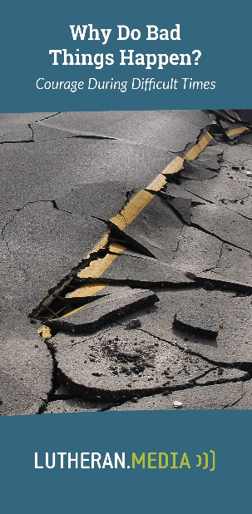  https://messagesofhope.org.au/why-do-bad-things-happen-booklet/ | 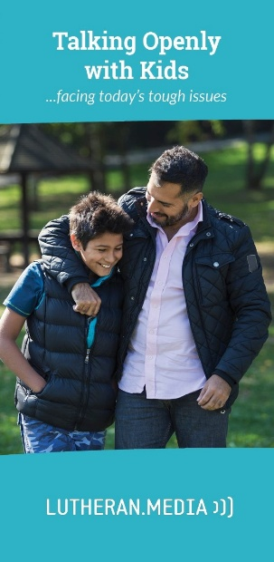  https://messagesofhope.org.au/talking-openly-with-kids-booklet/
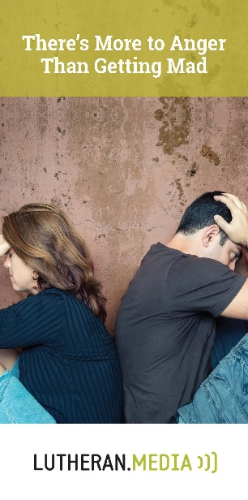  https://messagesofhope.org.au/theres-more-to-anger-than-getting-mad-booklet/ | 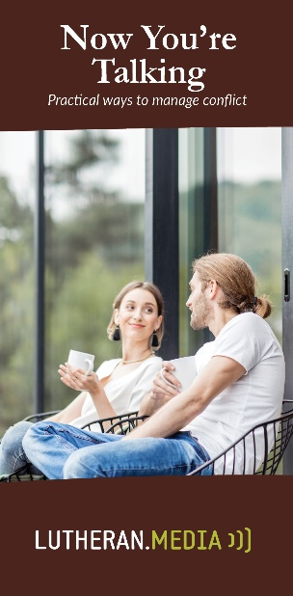  https://messagesofhope.org.au/now-youre-talking-booklet/

