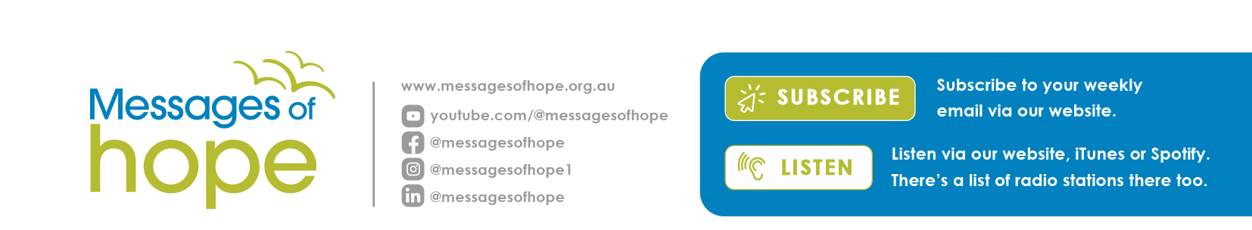
Messages of Hope in July 2024

7th July | Connecting Our Cultures | (Interview)
Rob Borgas has worked with indigenous communities for over 35 years. Hear his reflections on how indigenous and other cultures connect through love of language, family dynamics, and a shared faith.
14th July | Reconciling Relationship Conflict | (Interview)
“If I would have known these things earlier, I'd think I'd still be married.” Listen to Paul Kerber who has worked in reconciliation. Despite some of the most difficult scenarios, there is hope for your relationships.
21st July | Send Me an Angel | (Interview)
“It'd be great if depression was purely logical: ‘follow three simple steps and everything will be okay!’” Although depression isn't simple, it doesn't mean it's hopeless. Jane shares about her depression and what it took to find motivation again.
28th July | Out of the Cyclone | (Interview)
Hear John’s story of helping his family through the cyclone of depression. Hear how he navigated through the impact on the family and where they found hope through the struggle.

Lutheran Media June Appeal – Thank You!

Lutheran Media exists to create a world where every
individual finds hope, comfort, and purpose through the
power of uplifting and transformative content.

We give thanks for all those who helped us work towards
our goal of $200,000 raised for the work of Lutheran Media
and gospel-centred Messages of hope.
Your donation will help us to continue to reach all
generations through radio, podcasts, social media,
resources and more.

If you would still like to donate, please call us at 1800 353 350 or go to our website lutheranmedia.org.au.

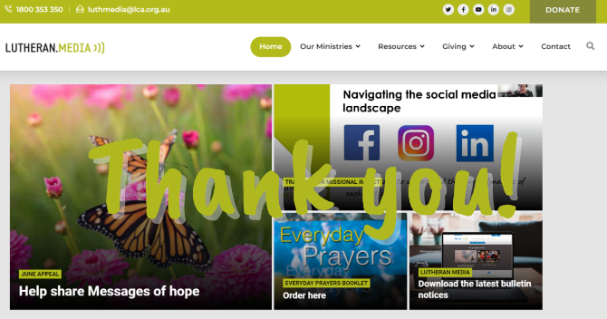

Prayer Requests
- For a pathway towards reconciliation.
- For those who are impacted by depression.

Videos in July

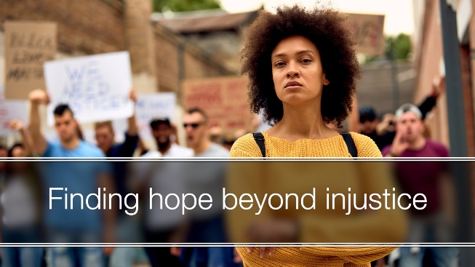  https://youtu.be/5lTg8m153Vc | 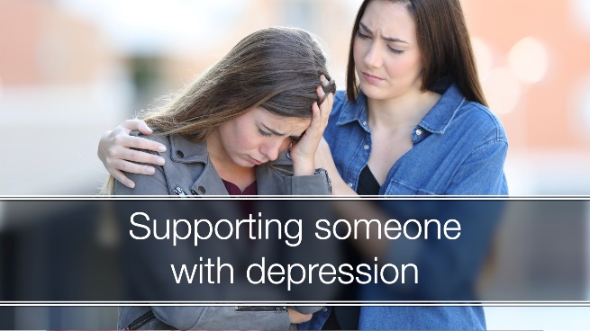  https://youtu.be/1-VOv6_VDOc

Booklets in July

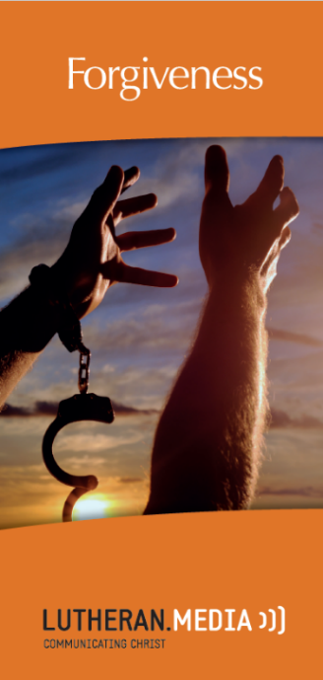  https://www.messagesofhope.org.au/forgiveness-booklet/ | 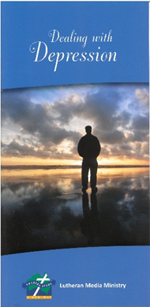  https://www.messagesofhope.org.au/dealing-with-depression-booklet/
