*Messages of Hope* 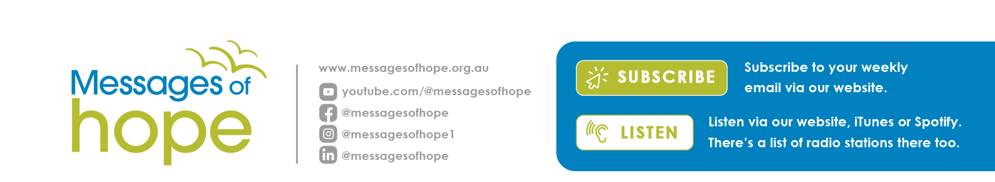in **October 2024**

|  |  |  |
| --- | --- | --- |
| **6th October** | **Teen Anxiety** | **(Interviews)** |
| Do you know a teenager with anxiety? Hear insights from teenagers living with anxiety – what it’s like for them, what helps and what doesn’t. | | |
| **13th October** | **Being Well** | **(Discussion)** |
| How is your well-being going, especially through these times? Listen to Anna, Celia and Richard talk about well-being and offering insights to help your well-being. | | |
| **20th October** | **Facing Fear** | **(Interview)** |
| Sarah McCutcheon, National Relationship Manager for Global Leadership Network Australia and renowned speaker, shares valuable insights into facing fear and embracing courage. | | |
| **27th October** | **Foster Parenting** | **(Interview)** |
| With foster care in high demand, hear Ann - mother of four, and a foster parent - share about the unique struggles and joys that come with foster parenting. | | |
|  | | |

**Lutheran Media Calendar 2025**

**NOW AVAILABLE!**

Hot off the press, our Lutheran Media Calendar for 2025 is now available to order. Full of inspirational images, bible reflections and messages of hope. The monthly pages provide ideal space to write your important dates and events.

Order online at <https://lutheranmedia.org.au/store/product/2025-scripture-calendar/> or call 1800 353 350.

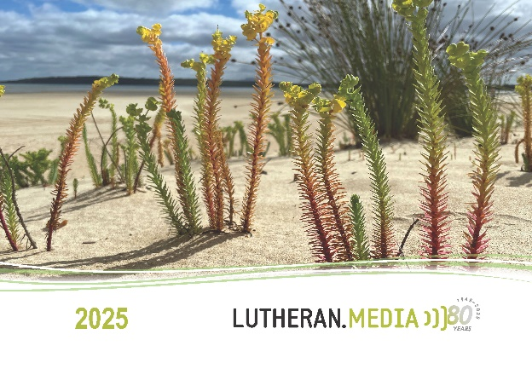

**Prayer Requests**

* **For people struggling with mental health issues.**
* **For those experiencing anxiety or fear.**
* **For the blessing of foster parents.**

Videos in **October**

|  |  |
| --- | --- |
| <https://www.youtube.com/watch?v=3t10qC-sWhk> | <https://youtu.be/ezaztm68r1g> |

Booklets in **October**

|  |  |
| --- | --- |
| <https://www.messagesofhope.org.au/no-need-to-fear-booklet/> | <https://www.messagesofhope.org.au/parenting-with-purpose-booklet/> |

