*Messages of Hope* in **November 2024**

|  |  |  |
| --- | --- | --- |
| **3rd November** | **Call Me Dad** | **(Rev Ben Hentschke)** |
| With over 46,000 children in foster care across Australia, this week we hear from Rev Ben Hentschke and his wife Kelly as they share their story of being long-term foster-carers. | | |
| **10th November** | **Nothing Normal** | **(Interview)** |
| For over 12 years, Tanya has cared for 33 foster children. Hear her story of challenges and joys as she opened her heart and her home to children in the foster care system. | | |
| **17th November** | **Smashing Plates** | **(Interview)** |
| One woman’s journey of healing from childhood trauma took her from a place of anger, frustration and helplessness to a place of restoration and hope. *\* sensitive content on domestic violence\** | | |
| **24th November** | **Domestic Violence** | **(Professor Sarah Wendt)** |
| No one is immune to domestic and family violence. Professor Sarah Wendt is dedicated to understanding the impacts of domestic violence and share her insights from personal stories about the causes and effects and where we may find hope in such a painful topic. *\*sensitive content advice\** | | |
|  | | |

**Lutheran Media Calendar 2025**

The ultimate Christmas gift for friends, family and colleagues. Get in quick as last year it ran out the door!

This calendar is full of inspirational images from photographers around the country. Complete with bible reflections and monthly pages with space to write your important dates and events.

Order online at <https://lutheranmedia.org.au/store/product/2025-scripture-calendar/> or call 1800 353 350.

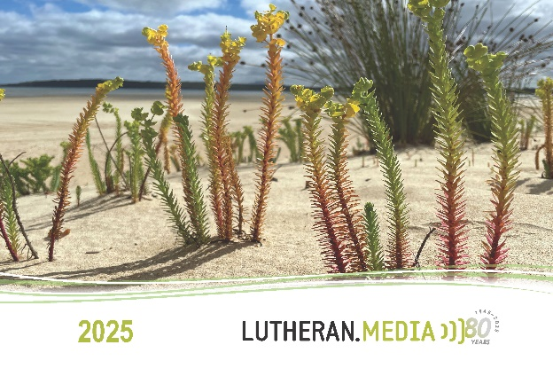

**Prayer Requests**

* **Give thanks for foster parents and pray for those they care for.**
* **For those impacted by domestic violence.**
* **For families needing encouragement and support.**

Videos in **November**

|  |  |
| --- | --- |
| <https://youtu.be/8xlJUXs6u_g> | <https://youtu.be/8ufpbFaK6mA> |

Booklets in **November**

|  |  |
| --- | --- |
| <https://www.messagesofhope.org.au/managing-anger-booklet/> | https://www.messagesofhope.org.au/has-god-abandoned-me-booklet/ |

