*Messages of hope* in **October 2025**

|  |  |  |
| --- | --- | --- |
| **5th October** | **Taking care of anger** | **(Interview)** |
| Do you ever feel like your emotions are in charge of you, rather than the other way around? Stella shares her journey of understanding and dealing with anger. | | |
| **12th October** | **Gone home** | **(Jonathan Krause)** |
| Death is not a topic that we talk about over a BBQ. Most of us don’t talk about death until it’s on our doorstep. Jonathan Krause shares his thoughts on why we don’t need to be afraid to have those conversations. | | |
| **19th October** | **Caring for Creation (part 3): Faith Communities** | **(Interview)** |
| Father Peter Moore actively supports caring for the environment and has been an inspirational advocate in his home congregation and community. Hear his perspective on how faith communities can make a real difference. | | |
| **26th October** | **80 years of Blessings** | **(Lutheran Media)** |
| Celebrating 80 years of Lutheran Media, we explore our beginnings and celebrate milestones. Hear how Lutheran Media has blessed radio, and media throughout the decades. | | |

**Lutheran Media 2026 Calendars – Available NOW!   
Be one of the first to order our 2026 Lutheran Media Calendar fresh off the press!**

This issue is full of inspiring images and bible verses with space to write your important diary dates. It’s a centrepiece worthy of prominence in any household!

To order, go to [www.lutheranmedia.org.au/calendar](http://www.lutheranmedia.org.au/calendar) or contact us at [office@lutheranmedia.org.au](mailto:office@lutheranmedia.org.au) or phone 1800 353 350.

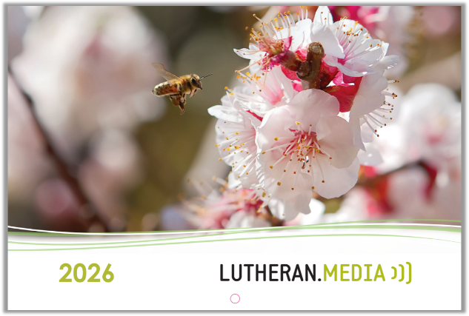

**Prayer Requests**

* **For people struggling to control their anger.**
* **For people living in fear or worried about the future.**
* **For the preservation of God’s glorious creation.**
* **For the continued ministries of Lutheran Media and Messages of hope.**

Resources in **October**

|  |  |
| --- | --- |
| <https://messagesofhope.org.au/theres-more-to-anger-than-getting-mad-booklet/> | <https://messagesofhope.org.au/take-heart-in-your-grief-booklet/> |

Special edition **80th Anniversary** history book:

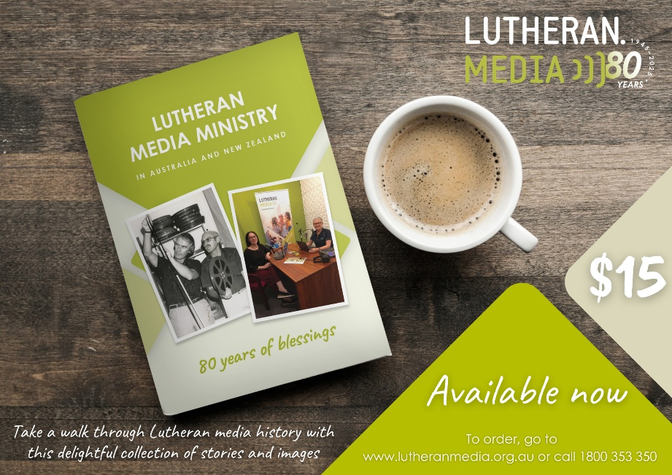

https://lutheranmedia.org.au/store/product/80-years-of-blessings/ 